15.41: a) The traveling wave is
The general equation for a standing wave is 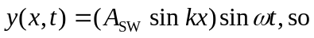

b)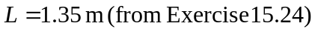
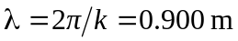
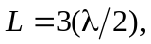so this is the 3rd harmonic
c) For this 3rd harmonic, 